Image Database

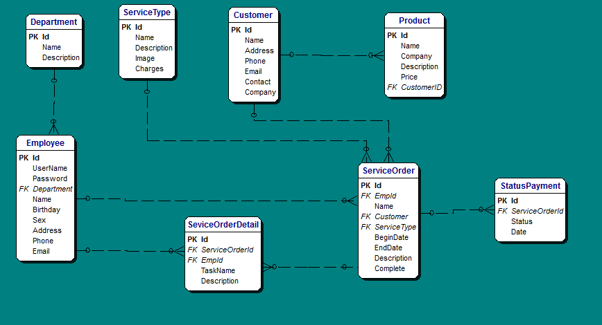

Diagram
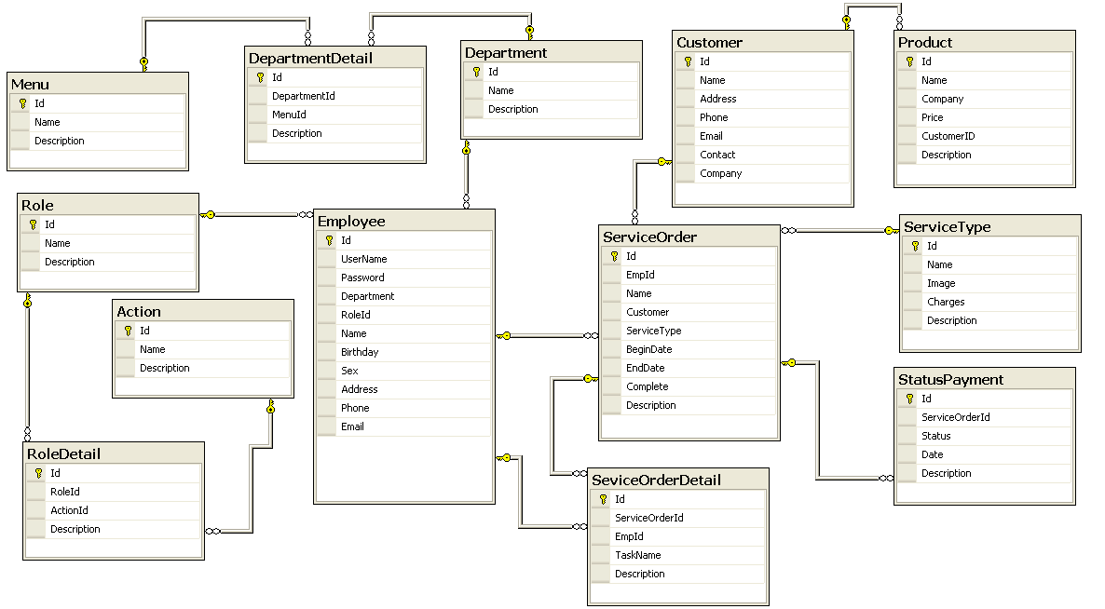

Description
1/Service Order Detail
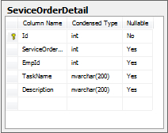
No. | Field Name | Description
01 | Id | Number of Account
02 | ServiceOderID | Number of ServiceOder
03 | EmpId | Number of Account Employee
04 | TaskName | TaskName of Account
05 | Description | Description of Account
2/Product
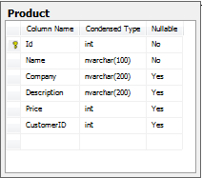
No. | Field Name | Description
01 | Id | Number of Account (Product)
02 | Name | Name of Account (Product)
03 | Company | Company Name of Product
04 | Description | Description of Product
05 | Price | Price of Product
06 | CustomerID | CustomerID of Product

3/Customer
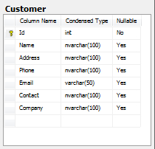
No. | Field Name | Description
01 | Id | Number of Account
02 | Name | Name of Account (Customer)
03 | Address | Address of Customer
04 | Phone | Number Phone of Customer
05 | Email | Email of Customer
06 | Contact | Contact of Customer
07 | Company | Company of Customer

4/Employee
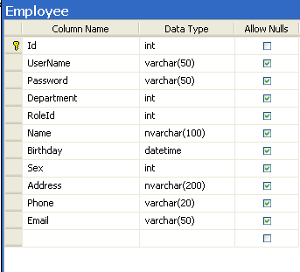

No. | Field Name | Description
01 | Id | Id of Employee
02 | UserName | UserName of Employee
03 | Password | Password of Employee
04 | Department | Department of Employee
05 | Name | Name of Employee
06 | Birthday | Birthday of Employee
07 | Sex | Male or Female of Employee
08 | Address | Address of Employee
09 | Phone Phone | Phone of Employee
10 | Email | Email of Employee
11 | Role | ID of role

5/ServiceOrder
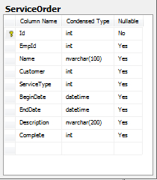
No. | Field Name | Description
01 | Id | Id of ServiceOrder
02 | EmpId | EmpId of ServiceOrder
03 | Name | Name of ServiceOrder
04 | Customer | Customer of ServiceOrder
05 | ServiceType | ServiceType of ServiceOrder
06 | BeginDate | BeginDate of ServiceOrder
07 | EndDate | EndDate of ServiceOrder
08 | Description | Description of ServiceOrder
09 | Complete | Complete of ServiceOrder

6/ServiceType
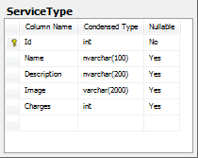
No. | Field Name | Description
01 | Id | Id of ServiceType
02 | Name | Name of ServiceType
03 | Description | Description of ServiceType
04 | Image | Image of ServiceType
05 | Charges | Charges of ServiceType

7/Department
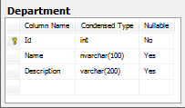
No. | Field Name | Description
01 | Id | Id of Department
02 | Name | Name of Department
03 | Description | Description of Department

8/StatusPayment
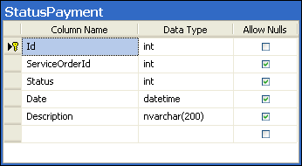
No. | Field Name | Description
01 | Id | Id of StatusPayment
02 | ServiceOrderID | ServiceOrderID of StatusPayment
03 | Status | Status of StatusPayment
04 | Date | Date of StatusPayment
05 | Description | Description of Status Payment

9/Menu

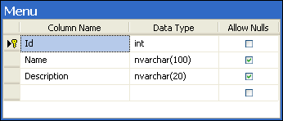

No. | Field Name | Description
01 | Id | Id of Menu
02 | Name | Name of Menu
03 | Description | Description of Menu

10/Role

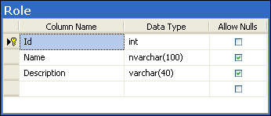

No. | Field Name | Description
01 | Id | Id of Role
02 | Name | Name of Role
03 | Description | Description of Role

11/Action

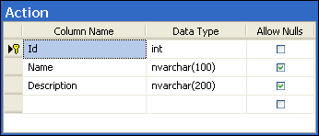

No. | Field Name | Description
01 | Id | Id of Action
02 | Name | Name of Action
03 | Description | Description of Action

12/RoleDetail

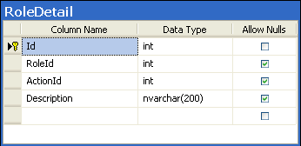

No. | Field Name | Description
01 | Id | Id of RoleDetail
02 | RoleId | Id of Role
03 | Description | Description of RoleDetail
04 | ActionId | Id of Action

13/DepartmentDetail

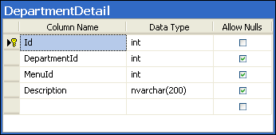

No. | Field Name | Description
01 | Id | Id of DepartmentDetail
02 | DepartmentId | Id of Department
03 | MenuId | Id of Menu
04 | Description | Description of DepartmentDetail

